**IMU and LRF Mapping**

1. Roscore Execution 2

2. Program Compile build 3

3. Hokuyo LREF Sensor Execution 4

4. IMU Distance measurement Module execution 5

5. LRF(hokuyo) Sensor data receiving and dynamixel execution 7

6. GUI view execution 8

7. TF ➢좌표 변환 9

8 Octree setting 10

## 1. Roscore Execution

1. 터미널창에서 "roscore"를이용해서 ROS 프로그램실행

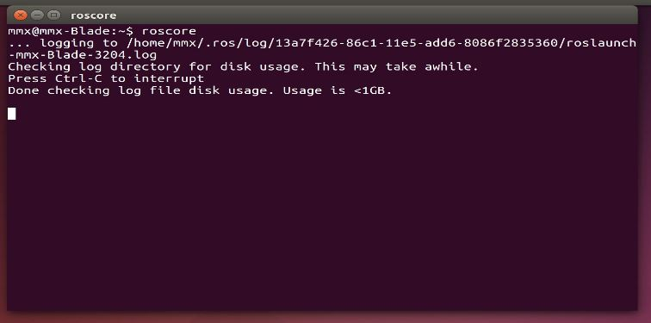

fig.1.ROS program execution

*command: roscore

## 2. Program Compile build

1. “cd catkin_ws/”입력하고, 폴더이동
2. “catkin_make”입력하고, 프로그램컴파일

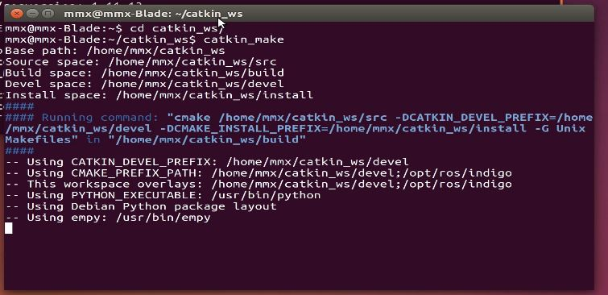

fig.2. Program build

*command: cd catkin_ws

*command: catkin_make·

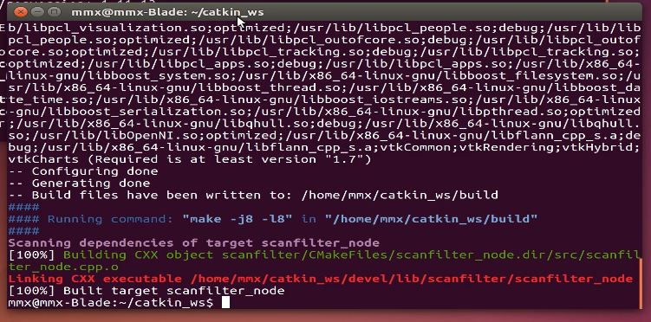

fig.3. Program build complete

## 3. Hokuyo LREF Sensor Execution

Start a new terminal and run commands.

1. “sudo chmod a+wr /dev/ttyACM0”입력후 Sensor 이용권한허가

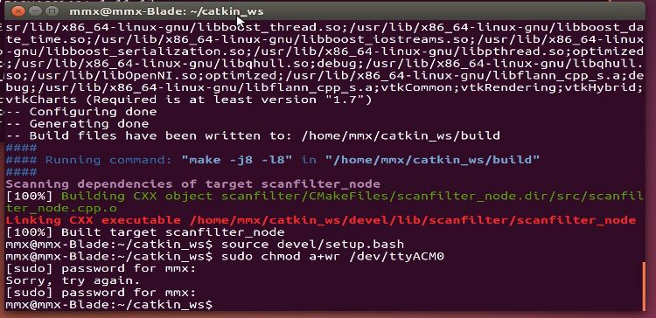

fig.4. Sensor use permission

1. -“rosrun hokuyo_node hokuyo_node” 입력, hokuyo_node실행

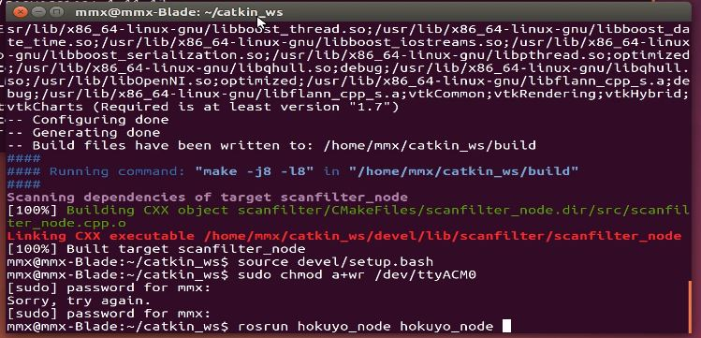

fig.5.hokuyo node execution

*command: sudo chmod a+wr /dev/ttyACM0

*command: rosrun hokuyo_node hokuyo_node

## 4. IMU Distance measurement Module execution

Start a new terminal and Enable the USB port(set the permission)

1. Run “sudo chmod a+rw /dev/ttyUSB1” , Here the “USB1” means the usb port number which can be views by command “ls –l /dev/tty*”.

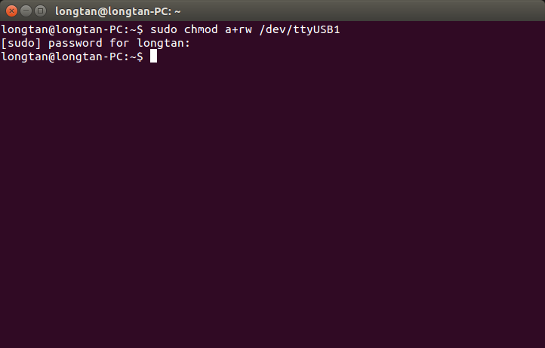

fig.6. IMU permission

Source the code

1. Run ”source catkin_ws/devel/setup.bash”

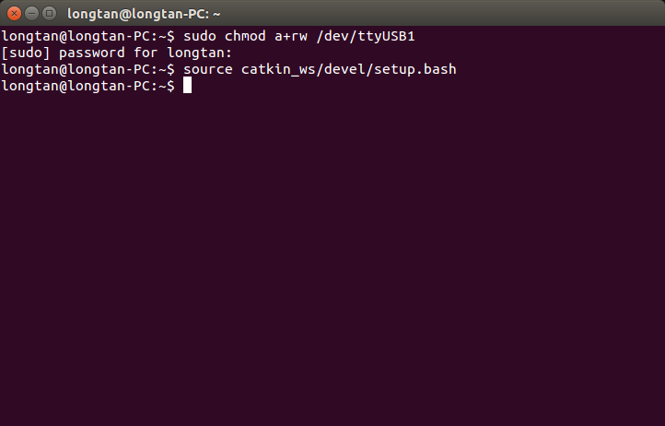

fig.7. Source the code

Run the module

1. Run ”rosrun imu imu.py /dev/ttyUSB1`” .

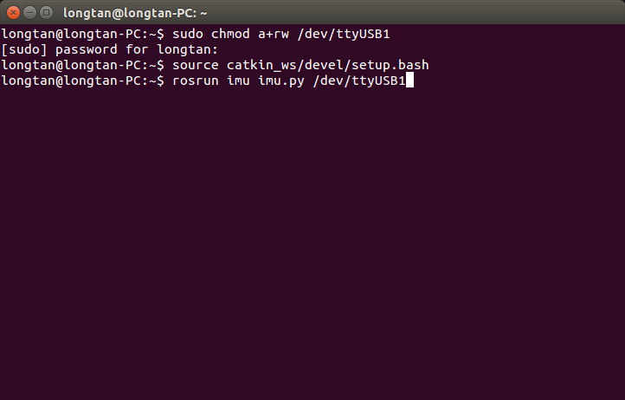

fig.8. IMU runing

command: sudo chmod a+rw /dev/ttyUSB1

command: source catkin_ws/devel/setup.bash

command: rosrun imu imu.py /dev/ttyUSB1

## 5. LRF(hokuyo) Sensor data receiving and dynamixel execution

LRF Sensor를 설치하고, Rviz프로그램에서 서보모터 구동한 후, Octree구동해서 맵을 작성

1. -Enable the Dynamixel usb port by command “sudo chmod a+wr/ dev/ttyUSB0”

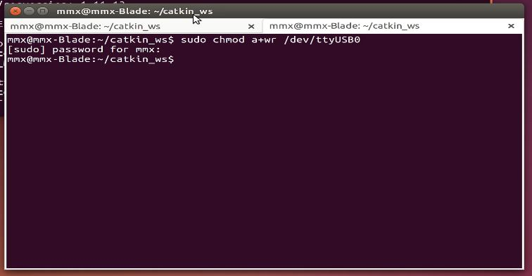

fig.11. USB Port use permission

1. - Source the code by command “source catkin_ws/devel/setup.bash”
2. -run LRF(hokuyo) Sensor data receiving and dynamixel codes by command ”rosrun scanfilter scanfilter_node /dev/ttyUSB0”

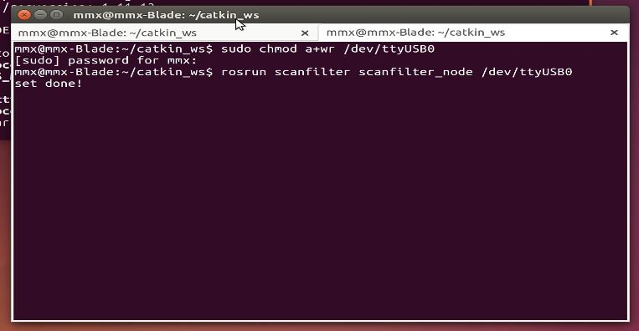

fig.12. USB Port setting and dynamical

*command: sudo chmod a+wr/ dev/ttyUSB0

*command: source catkin_ws/devel/setup.bash

*command: rosrun scanfilter scanfilter_node /dev/ttyUSB0

## 6. GUI view execution

1. start a new terminal and “rosrun rviz rviz” command and rviz program execution

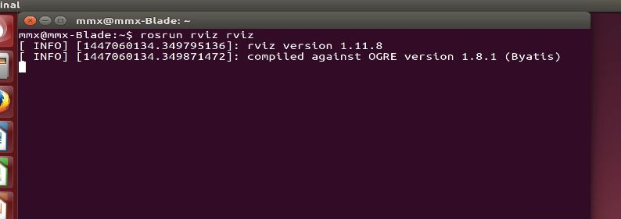

fig.13.rviz program execution

command: rosrun rviz rviz

## 7. TF ➢좌표 변환

* 좌표 변환

좌표 변환을 설정한 후, Octree 설치 하고 실행.

1. "rosrun tf static_transform_publisher 0 0 0 0 0 0 map dynamixel 30", command and password

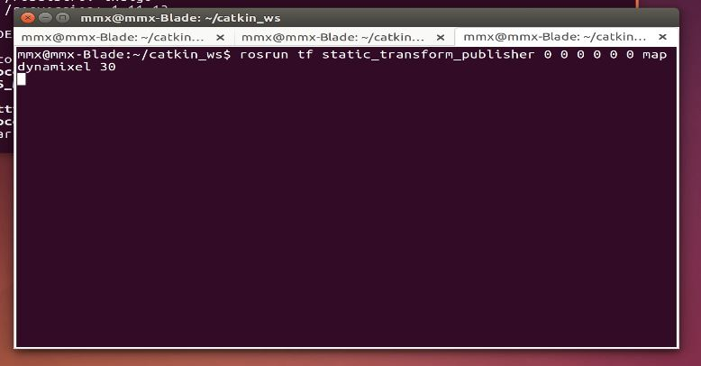

fig.14. Command complete

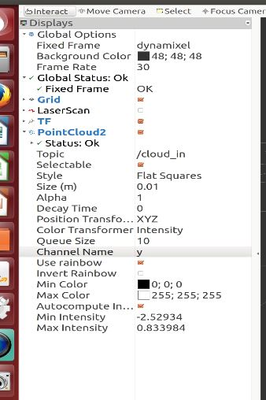

Fig.15.Check the information frame rate

*command: rosrun tf static_transform_publisher 0 0 0 0 0 0 map dynamixel 30

## 8 Octree setting

1. Open a new terminal and run “rosrun octomap_server octomap_server_node”
2. Set the gui Point cloud topic to “octomap_point_cloud_centers”

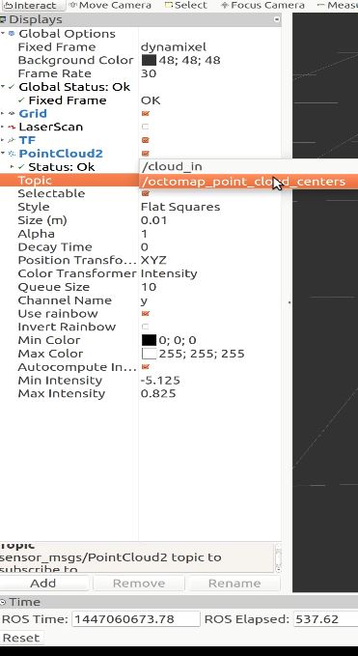

fig.16. Rviz topic change octomap point cloud centers

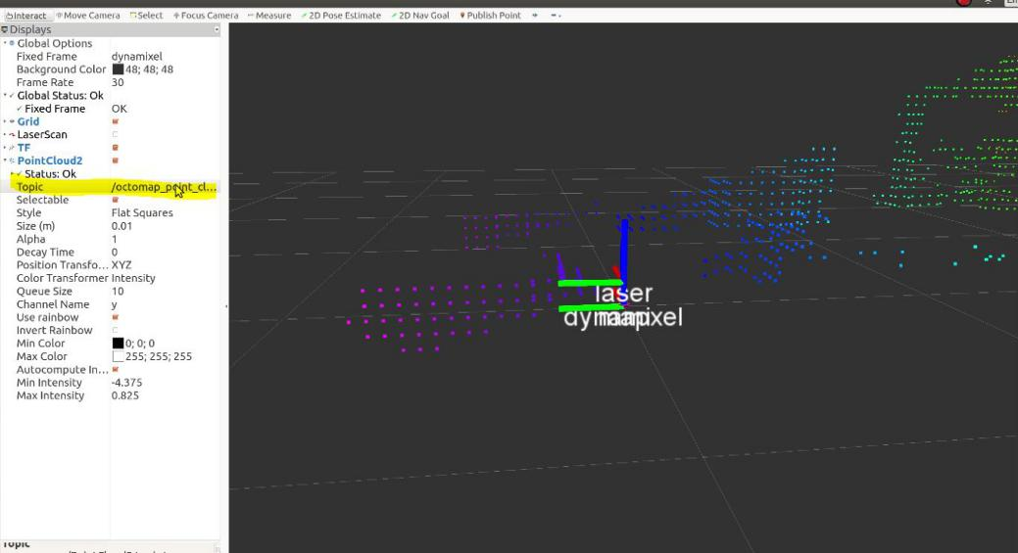

fig.17.Rviz octree servis

*command: rosrun octomap_server octomap_server_node